**Canadian language attitudes from “coast to coast to coast”: on the pluricentricity of English in North America**

Stefan Dollinger & Lars Hinrichs

# 1 Introduction

Sociolinguists are not immune to wider social developments. One can argue, for instance, that the era of the free trade negotiations of the 1980s and early 1990s[1] are reflected in sociolinguistic theories at the time. While the first generation of Canadian linguists tended to emphasize differences (e.g. Avis et al. 1967, Scargill 1974), the linguistics of Canadian English has seen a subtle but steady influence to that effect as of the early 1980s. The early period was marked by bold statements as to the weakness of Canada-US border as a linguistic divide (e.g. Warkentyne & Brett 1981: 307; Chambers 1980: xxx, Warkentyne 1983: xxx), or even to its irrelevance (e.g. Woods 1993: xxx). The latter point has been occasionally echoed in more recent writings (e.g. Sadlier-Brown 2012: xxx). What unites these claims, however, is the lack of a comparative US sample in addition to the Canadian sample, which means that US usage is inferred from indirect evidence only (e.g. dictionary and usage guides, general impressions) but not data collected in the same way as on the Canadian side. If a more appropriate design is brought forth to study cross-border linguistic influences, however, it is almost always shown that the veracity of the Canada-US border and its linguistic effects – subtle yet consistent – can be clearly shown (e.g. Chambers 1994, 2000; Boberg 2000, Boberg 2005, Boberg 2008; Dollinger 2012).

In the context of pluricentric languages, it is noteworthy that “contiguous varieties”, e.g. varieties that border on other varieties such as Canadian and American English, Austrian German and German German and Netherlandic and Belgian Dutch, have traditionally been faced with disciplinary scepticism (e.g. xxx). In this context, “non-contiguous varieties”, i.e. those separated by a sea border such as Australian and New Zealand English, or Irish English and English English, have had an easier time being recognized. Such questions of dominance (heteronomy) or non-dominance (autonomy) are part and parcel of the sociolinguistic theory of linguistic pluricentricity. The present paper sees itself as a contribution to this large and growing oeuvre (e.g. Clyne 1984, 1995, Ammon et al. 2004, Muhr 2012, Dollinger 2019).

Based on a language attitudinal questionnaire, the present paper explores notions of the “standard” for Canadian English and notions of linguistic autonomy as central tenets of pluricentric theory. It is structured in the following way: it will first introduce the constraints of the present data set, collected in the fall (October and November) 2023. It will then present the main results, correlations and modelling effects for the 3000-respondent-survey. In a next step, the findings will be put into the context of existing literature on language attitudes and perceptions and Canadian English, before, the findings will be interpreted in the larger framework of the sociolinguistic theory of pluricentricity, which is occasionally critiqued as nationalistic (e.g. Schneider 2022) or misunderstood (e.g. Elspaß 2025, Herrgen 2015). It will be highlighted that pluricentricity has been the dominant approach in the sociolinguistics of World Englishes and that other concepts, purported to stand in competition or to “complement” pluricentricity, appear in philological frames that face decolonial and dehegemonic challenges. Where conducive, data from other languages, e.g. Austrian German or Belgian Dutch, will be brought in to recognize the special role of what since Clyne/Muhr are often referred to as “non-dominant” varieties.

# 2 Pluricentric theory

In English, two varieties can be considered dominant today: Standard English English and Standard American English. All other varieties, including Standard Canadian English, are non-dominant varieties (e.g. Clyne 1992, originally called “dominant” and “other” varieties”).

# 3 The data

# 4 Results: the attitudinal autonomy of CanE

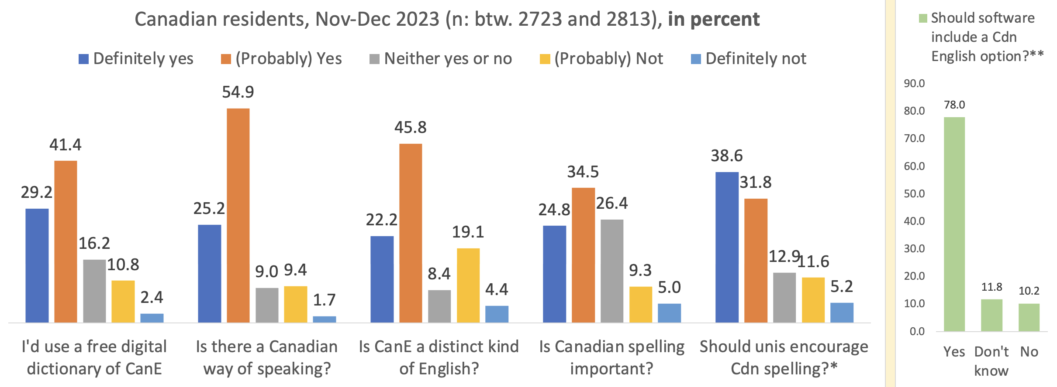

Fig. 1: Large majorities confirm questions on the linguistic autonomy of CanE among the Canadian residents.

Compared with those who spent the majority of their formative years (Ages 0-18) in Canada, the approval rates are low:

For instance, for the question “Is there a Canadian way of speaking?” the differential between residents, which include new arrivals and transient students/workers, and formative years in Canada are generally in the 20% point range or more:

|  |  |
| --- | --- |
|  |  |
| Fig. 2: By Canadian residents | By formative Region in Canada (Ages 8-18) |

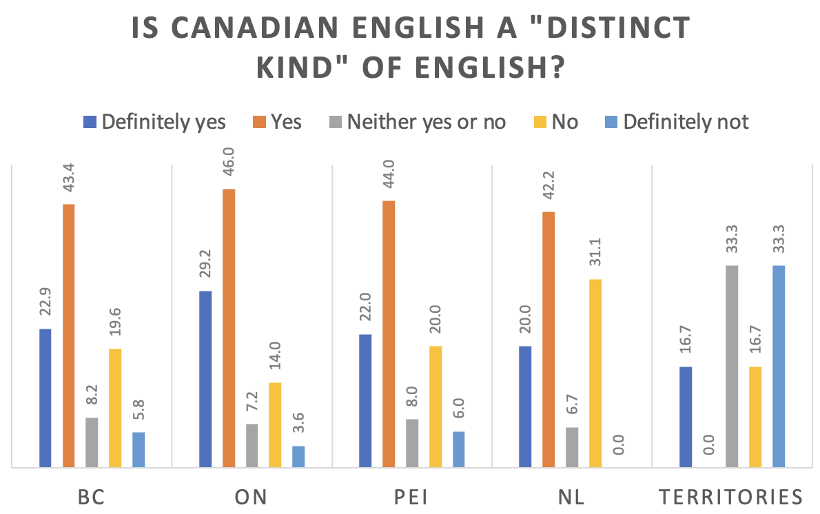

Territories as a linguistic frontier: different from the rest of the country (by formative region)

# 5 Conclusion

# 6 References

1. Canada-US Trade Agreement in 1988, NAFTA in 1994, the European Union 1993 and the founding of the World Trade Organization in 1995 *punctuation*